Report Week 3

Achievements:
- Got 3GB of extra storage space from IT services
- Writing data to SDRAM partition INPUT_DATA (id=1) works
- Cores reading data from SDRAM partition INPUT_DATA works
- Cores recording data back to SDRAM partition OUTPUT_DATA(id=2) works
- Host retrieving data back from SDRAM parition OUTPUT_DATA works
In a nutshell, loading data onto the SpiNNaker and retrieving it works seamlessly.
This is quite a milestone, since I can focus more on the development of algorithms and data processing within the C code now (or vertices for that matter) as opposed to spending a lot of time with configuration and data flow issues.
I also included two screenshots on page 2 to prove this point.

Goals for next week:
- Perfect the data transfer so that more data can be handled than currently possible
- Once this is solved (e.g. by establishing a data transfer protocol), start the implementation of basic queries
- Investigate the possible use of spikes for performing queries (e.g. for sum operations)

Those queries will be something like searching for a specific data item (or instances of data items) across the data base or returning a histogram of data items

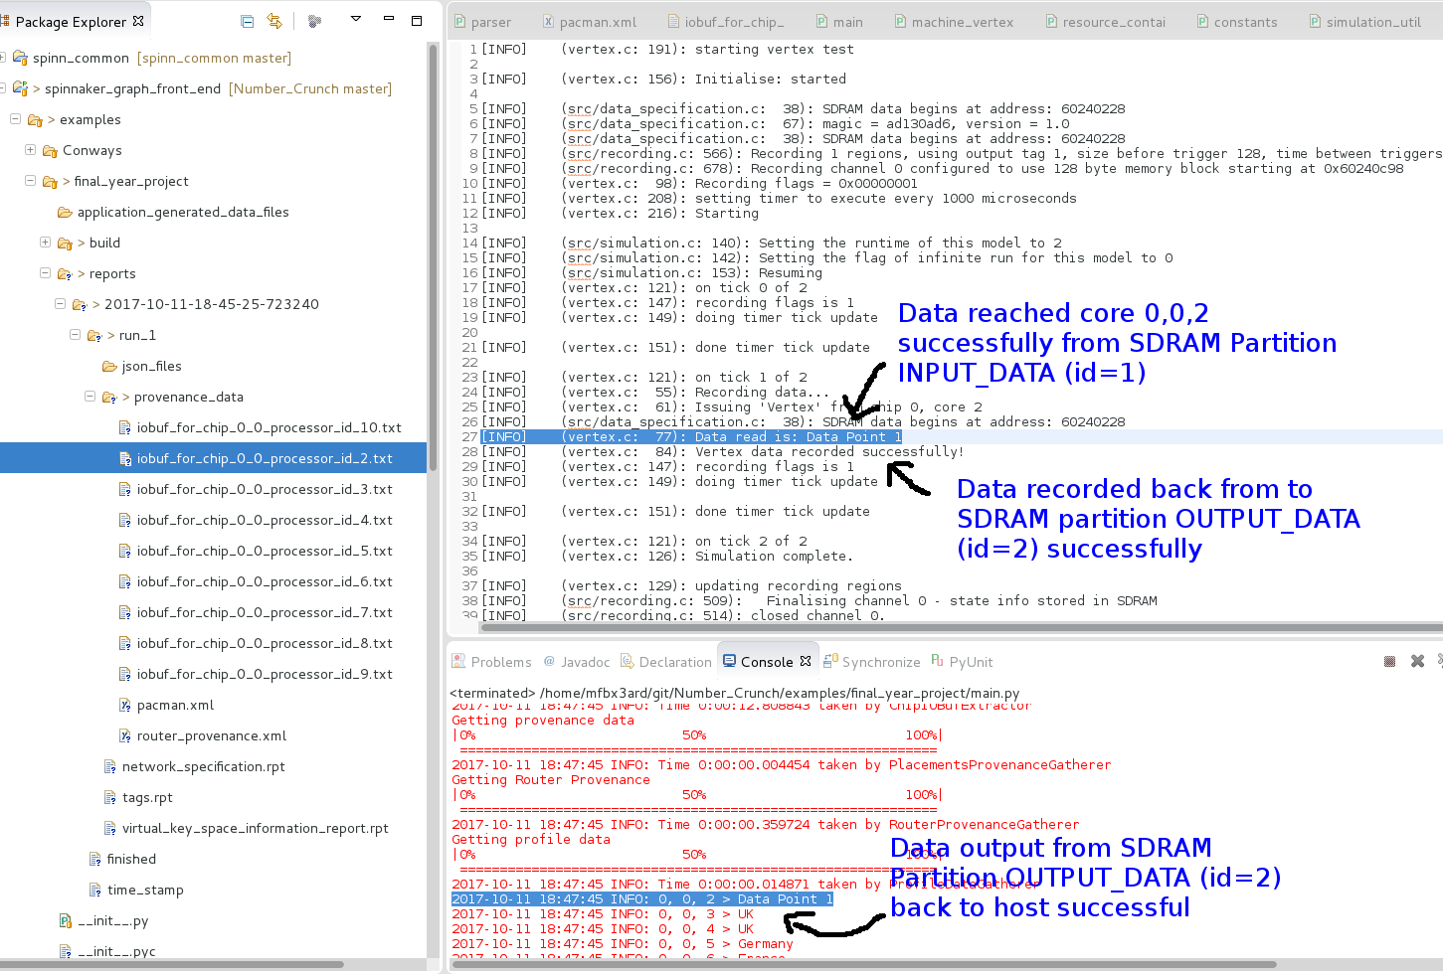
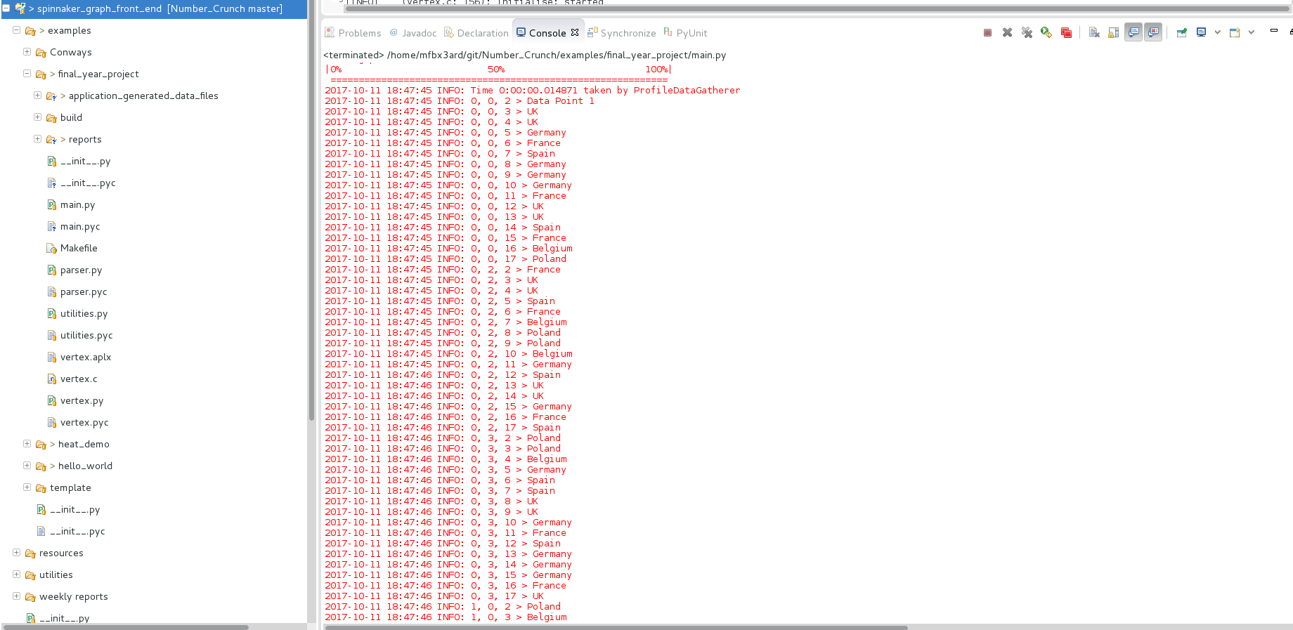
Each vertex responds with a (16 bit) data entry that was assigned to it:

